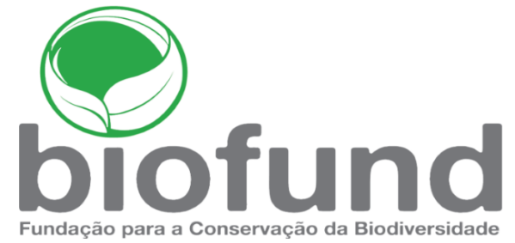

NOMINATION FORM
1st RANGERS SUPPORT FUND AWARDS 2021

The Rangers Support Fund, also known as the Dr. Carlos Lopes Pereira Fund, was created in 2020 with the aim of recognizing, motivating and rewarding the bravery and dedication of rangers from Mozambique's public and private Conservation Areas, through a yearly award. This fund is managed by the Foundation for the Conservation of Biodiversity - BIOFUND.
The awards are intended for rangers and forest guards working in any of the country's Conservation Areas, including those under public management (Parks, Reserves, APAs and others), those under private management (Coutadas, Niassa hunting blocks, Fazendas de Bravio, Total Protection Zone), and those under community management.
The awards aim to identify and highlight the rangers who have not only worked in an exemplary way throughout their career, but who also stood out during the year 2020 with exceptional and concrete actions, which thus serve as an example of zeal, determination, bravery and courage for all rangers in the country.
The selection of winners for the Dr. Carlos Lopes Pereira Fund awards will be at the discretion of the jury after evaluating the applications received.

ELEGIBILITY
1. The nominee must be proposed by the Conservation Area Administrator or Manager (in the case of CAs managed by the private sector) upon proposal of the collective and/or supervisor;
2. The nominee must be a Mozambican citizen, exercising the functions of active ranger/forest guard (including sworn and non-sworn rangers);
3. The nominee must be working as a ranger at the time of his nomination and work for more than three years in the same Conservation Area;
4. The nominee must not have been subject to any disciplinary proceedings in the last 3 years;
5. Each CA can appoint only one nominee;
6. Team nominations will not be eligible;
7. In the case of CAs managed by the private sector, they must be a member of AMOS.

SELECTION CRITERIA
- Commitment and dedication
Express enthusiasm and competence to work as a ranger, fulfilling all daily duties in an exemplary manner;

- Impact and contribution
Contribute significantly to the protection of fauna and habitats, promoting conservation in local communities or other essential work for conservation;
- Threats and challenges overcome
Courageously responding to serious and life-threatening danger at work; effectively addressing challenges to combating wildlife damage;
- Leadership and inspiration
Performing above expectation of her/his duty; demonstrating the ability to influence, motivate, and lead team members.

TO NOMINATE A CANDIDATE, SEND TO conservação@biofund.org.mz with the subject: RANGERS SUPPORT FUND-APPLICATION:
- Nomination Form;
- Materials demonstrating the nominee's work (link to images, videos, newspaper clippings and other relevant). If you would like to upload multiple files, please compress all the files into a ZIP file before uploading.

TIMELINE OF THE APPLICATION PROCESS
6

5

4

3
2

1

Award CEREMONY
31/Julho/2021
Winners ANNOUNCED
15/July/2021
JUDGING of
applications
08-10/July/2021
PRELIMINARY
Screening
06-07/July/2021
Submission CLOSES
05/July/2021
Submission OPENS
11/June/2021

For further information or to ask any questions, please e-mail conservação@biofund.org.mz

NOMINEE PERSONAL INFORMATION
All information shall be about the nominee ranger
Full Name
Gender | ☐ Male  ☐ Female | Date of birth | Click or tap to enter a date.
Employer |  | Job title
Training description
CA where the ranger is based (Name of CA)
Years of service |  | Years of service in this CA
Performance Evaluation Rating of the last 3 years (if applicable)
Phone number  (Optional) |  | E-mail address  (Optional)
Please confirm whether the nominee’s stories can be shared with the public ☐ Yes ☐ No
NOMINATOR INFORMATION
All information shall be about the nominator
Full Name
Employer |  | Job title
CA where the nominator is based (Name of CA)
Phone number |  | E-mail address
Number of years that you know the nominee
PREFERRED PRIMARY CONTACT
Please enter the contact details of the person in charge of responding on this matter (if different from the nominator)
Full Name
Employer |  | Job title
Phone number |  | E-mail address

TELL US MORE ABOUT THE NOMINEE
Answer all questions with a clear and detailed description
How did you meet your nominee and how long and in what capacity have you known him?
How long has your nominee worked as a ranger and in what position? How has his/her behavior and performance been during his/her career?
In this last year, what were the concrete threats and challenges that your nominee overcame? How did he/she stand out?
What achievements your nominee has made this year that benefit conservation in Mozambique? Also clearly state its impact.
How does your nominee show his/her qualities in leadership/inspiration to the colleagues?
What other attributes did your nominee demonstrate that qualify him/her to be honored with the Dr Carlos Lopes Pereira 2021 Awards?
Is there anything else about your nominee that you would like the committee to consider? (Optional)

HIGHLY RECOMMENDED SUPPORTIVE DOCUMENTS
We encourage you to send us along with this form any documents/photos/videos that may demonstrate your nominee's work. If you plan to upload multiple documents, compress them all into a ZIP file before uploading. (Optional)
DECLARATION BY THE NOMINATOR
☐ Everything contained in this application is true and correct to the best of my knowledge at the time of submission.

____________________________________ ____________________________________
Signature of the Nominator Signature of the Nominee

For further information or to ask any questions, please e-mail conservação@biofund.org.mz

